Design Thinking Project Report on

TRANSPORTATION BOT
Submitted to
The Department of Computer Science and Engineering
Bachelor of Technology
in
Computer Science and Engineering
(2021 – 2025)
M VARSHITH 21R11A05D4
CH SHIVA KUMAR 21R11A05B8
G SRINIVAS KOUSHIK 21R11A05C3

Under the Guidance of
Dr. G. Kalyani and M. Vishvashanti

Department of Computer Science and Engineering
Accredited by NBA
Geethanjali College of Engineering and Technology (UGC Autonomous)
(Affiliated to J.N.T.U.H, Approved by AICTE, New Delhi)
Cheeryal (V), Keesara (M), Medchal.Dist.-501 301.
July-2023

Abstract
In small-scale industries and startups, investing a substantial amount of capital on conveyor belts for transporting heavy objects weighing up to 1 to 1.5 tons can be financially challenging. To address this issue, we propose the development of a project called "Transportation Bot." The Transportation Bot is a cost-effective and autonomous robot designed to carry heavy loads, replacing traditional conveyor belts.The Transportation Bot functions by autonomously following a designated line, which allows it to navigate through the industry seamlessly. By operating as an independent unit, it significantly reduces the space required for material transportation compared to conventional conveyor systems. Additionally, the robot is equipped with obstacle detection capabilities, ensuring a smooth and conflict-free operation within the industrial setting.This innovative solution provides small-scale industries and startups with a more affordable, space-efficient, and autonomous alternative for heavy load transportation. The Transportation Bot's ability to carry heavy weights and navigate autonomously makes it a promising prospect for enhancing efficiency and productivity in various industrial settings, promoting cost-effectiveness and streamlined operations.

LIST OF FIGURES
S.No | Fig.No | Title of Figure | Page.No
1

LIST OF TABLES
S No | Table No. | Title of Table | Page No.

INDEX

Abstract i
List of Figures ii
List of Tables iii

1.INTRODUCTION 1

1.1 Scope

1.2 Existing System

1.3 Proposed System

2.SYSTEM ANALYSIS

2.1 Functional Requirement Specifications

2.2 Performance Requirements

2.3 Software Requirements

2.4 Hardware Requirements

3.SYSTEM DESIGN

3.1 Architecture Design

3.2 Modules

4.SYSTEM IMPLEMENTATION

5.OUTPUT SCREENS

6.CONCLUSION AND FUTURE SCOPE

BIBLIOGRAPHY

1. INTRODUCTION

Transportation Bot is an idea implemented to contribute in reducing one of the major problem today that is cost of investment in conveyer belts in manufacturing industries at start-ups. Investing in conveyer belts is very huge capital investment and its maintainence is also high .After the post pandemic time the labour cost is also very high for skilled works .So, to avoid this and to automate industry we came up with this.

  - Scope

The primary objective of the project is to design and develop an autonomous robot capable of carrying heavy loads, replacing traditional conveyor belts in small-scale and startup industries. The robot will follow a designated black line path using IR sensors for navigation and halt when encountering a perpendicular line to avoid collisions. The project involves building a robot equipped with IR sensors for line following capabilities, an Arduino microcontroller to process sensor data and control motor movements, and an ultrasonic sensor to detect obstacles in the robot's path. Implementing an efficient line following algorithm using IR sensors to detect the black line on the ground. The robot will continuously monitor sensor data to maintain its position on the designated line. Integrating the ultrasonic sensor with the Arduino microcontroller to sense obstacles in front of the robot up to a range. The microcontroller will process the sensor data and instruct the motors to change direction to avoid collisions .Developing the control logic within the Arduino microcontroller to process input from IR sensors and the ultrasonic sensor, making decisions on speed, direction, and stopping based on the detected line and obstacle information. Utilizing a motor driver to control the robot's movement based on the commands received from the Arduino microcontroller. The motor driver will ensure precise control over the robot's speed and direction.

  - Existing System

Conveyor belts used in industries have several drawbacks when compared to the proposed "Transportation Bot" project. Firstly, conveyor belts require a significant initial investment, making them financially challenging for small-scale and startup industries. Conveyor belts have fixed routes, limiting their flexibility to adapt to changing production layouts, while the Transportation Bot's autonomous line-following capability allows for greater adaptability. Moreover, conveyor belts consume substantial floor space, which might not be suitable for constrained industrial environments, while the compact design of the Transportation Bot consumes significantly less space. Conveyor belts can be prone to wear and tear, leading to higher maintenance costs, whereas the robot with fewer moving parts might offer lower maintenance expenses. Additionally, conveyor belts face challenges in handling unexpected obstacles, which can lead to production interruptions, whereas the Transportation Bot's obstacle detection and avoidance system ensures smooth operations.

The following are the drawbacks of the existing system:

1. High Initial Investment: Conveyor belts require a significant initial capital investment, which can be financially challenging for small-scale industries and startups with limited resources.

2. Fixed Route: Conveyor belts have a fixed path, limiting their flexibility in adapting to changing production layouts or requirements. In contrast, the Transportation Bot can autonomously follow any designated line, offering greater adaptability.

3. Space Consumption: Conveyor belts occupy substantial floor space, which might not be feasible for smaller industrial setups. The Transportation Bot, being a compact robot, consumes significantly less space, making it suitable for constrained environments.

4. Maintenance Costs: Conveyor belts require regular maintenance and can be prone to wear and tear. The Transportation Bot, being a robot with fewer moving parts, could potentially have lower maintenance costs.

5. Limited Obstacle Handling: Conveyor belts can face difficulties in handling unexpected obstacles in their path, leading to potential production interruptions. The Transportation Bot's obstacle detection capability enables it to navigate around obstacles and maintain smooth operations.

6. Energy Consumption: Conveyor belts can consume substantial energy, contributing to higher operational costs. The Transportation Bot, depending on its design, may offer more energy-efficient transportation options.

7. Scalability: Conveyor belts might pose challenges in terms of scalability, especially if the production layout needs frequent modifications. The autonomous nature of the Transportation Bot allows for easier scalability and adaptability to changing production needs.

8. Integration with Existing Systems: Integrating conveyor belts into existing setups can be cumbersome and costly. On the other hand, the Transportation Bot can be implemented without significant disruptions to the current infrastructure.

  - Proposed System

The proposed system is designed to reduce the cost of investment and saves space where the bot can automatically on sensing the line follows it. Sometimes, we need to change the
production layout frequently . Therefore, we propose here a Transportation Bot project presents an innovative and cost-effective solution for small-scale and startup industries, offering increased efficiency, flexibility, and adaptability in heavy load transportation within industrial settings. This is achieved by using IR sensors. These sensors will be placed on the front side of the bot, which will in-turn detect the line to be followed and ultrasonic sensor checks for any obstacle and stops without hitting it and sends information to the microcontroller arudino uno.

MERITS-

1.Uses ir sensor and ultrasonic sensor.
2. No manual instructions.
3. Less cost.
4. Controlled transportation path.

2.SYSTEM ANALYSIS

- Functional Requirements:
Line Following: The robot should be capable of following a designated black line using IR sensors for precise navigation.
Obstacle Avoidance: The robot must detect obstacles in its path using ultrasonic sensors and take appropriate action to avoid collisions.
Autonomy: The Transportation Bot should operate autonomously without human intervention during the material transportation process.
Start/Stop Control: The robot should have the ability to start, stop, and pause its movement on the line as per the given commands.
Speed Control: The robot should be able to adjust its speed based on the production requirements and obstacle detection.

- Performance Requirements:
Line Following Accuracy: The robot should consistently maintain a high level of accuracy while following the black line.
Obstacle Detection Time: The ultrasonic sensor should detect obstacles promptly to ensure the robot can safely avoid collisions.
Response Time: The robot's control system should respond quickly to sensor inputs, ensuring smooth and efficient movements.
Load Capacity: The Transportation Bot should be designed to carry heavy loads up to 1 to 1.5 tons with stability and efficiency.

- Software Requirements:
Arduino Programming: Utilizing Arduino IDE to develop the code for the Arduino microcontroller, incorporating line following and obstacle avoidance algorithms.
Sensor Integration: Implementing code to process input from IR sensors for line following and ultrasonic sensors for obstacle detection.
Control Logic: Developing logic to make decisions based on sensor data, controlling motor movements and handling obstacle avoidance.
Autonomous Behavior: Creating a software module to enable the robot to operate independently, following the designated line and avoiding obstacles.

- Hardware Requirements:
Arduino Microcontroller: Using an Arduino board (e.g., Arduino Uno) to control the robot's movements and process sensor data.
IR Sensors: Installing infrared sensors to detect the black line on the ground for accurate line following.
Ultrasonic Sensor: Utilizing ultrasonic sensors to detect obstacles in front of the robot for collision avoidance.
Motor Driver: Employing a motor driver to control the motors' speed and direction for precise movement.
Chassis with 4 Wheels: Building a sturdy chassis equipped with four wheels to support the robot's movement.
Jumper Cables: Using male-to-male, male-to-female, and female-to-female jumper cables to establish connections between components.
Lead Wire and Soldering Gun: Employing lead wires and a soldering gun to make secure connections and assemble components.

4.SYSTEM IMPLEMENTATION

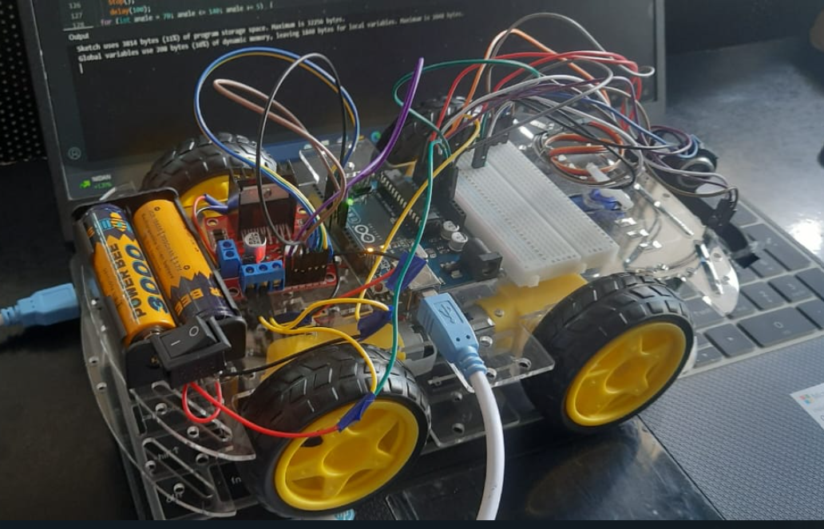

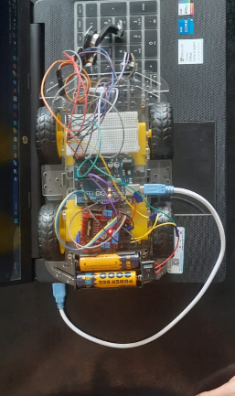

Source code:

const int xpin = A0;
const int ypin = A1;
onst int zpin = A2;
#define buzzer 11

void setup() {

pinMode(2,OUTPUT);
pinMode(3,OUTPUT);
pinMode(4,OUTPUT);
pinMode(5,OUTPUT);
pinMode(6,OUTPUT);
pinMode(7,OUTPUT);
pinMode(buzzer, OUTPUT);

}

void loop() {
int a,b,c;
a=analogRead(xpin);
b=analogRead(ypin);
c=analogRead(zpin);

if(a<=300)
{
Serial.print("left");
digitalWrite(11, HIGH);
digitalWrite(5, LOW);
delay(100);
digitalWrite(6, LOW);
delay(100);
digitalWrite(7, LOW);
delay(100);
digitalWrite(11, LOW);
delay(300);
digitalWrite(5, HIGH);
digitalWrite(6, HIGH);
digitalWrite(7, HIGH);
delay(300);
}
else if(a>=370)
{
Serial.print("right");
digitalWrite(11, HIGH);
digitalWrite(4, LOW);
delay(100);
digitalWrite(3, LOW);
delay(100);
digitalWrite(2, LOW);
delay(100);
digitalWrite(11, LOW);
delay(300);
digitalWrite(4, HIGH);
digitalWrite(3, HIGH);
digitalWrite(2, HIGH);
delay(300);
}
}

5.OUTPUT SCREENS

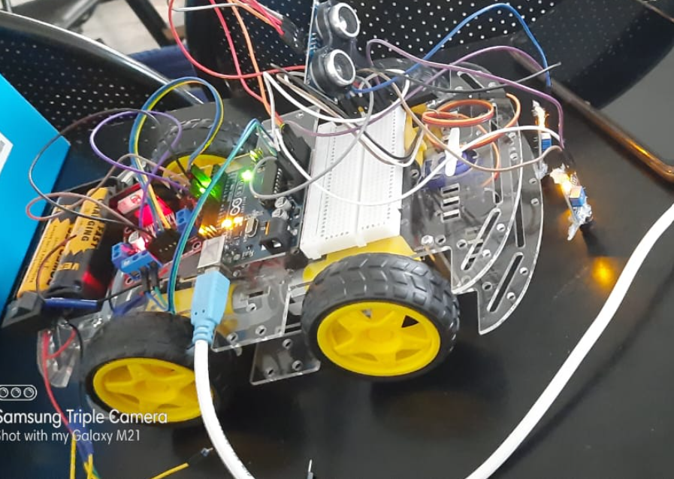

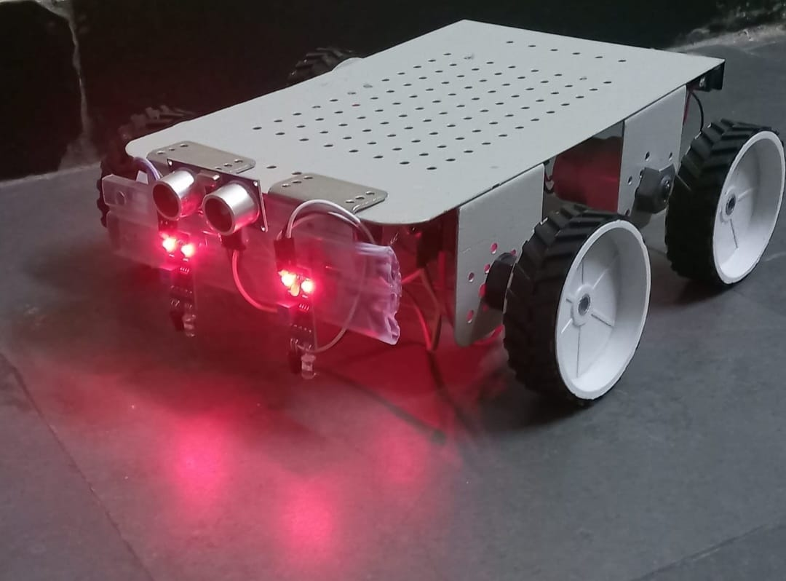
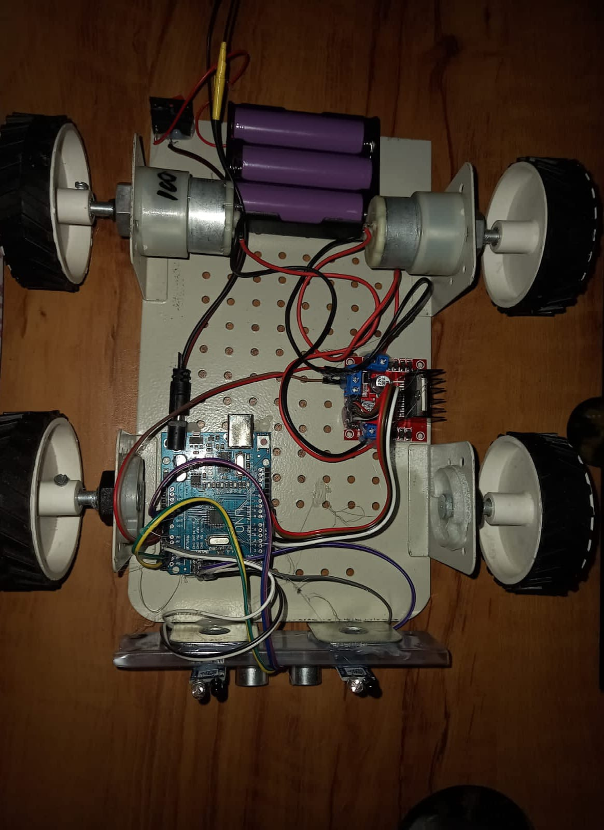

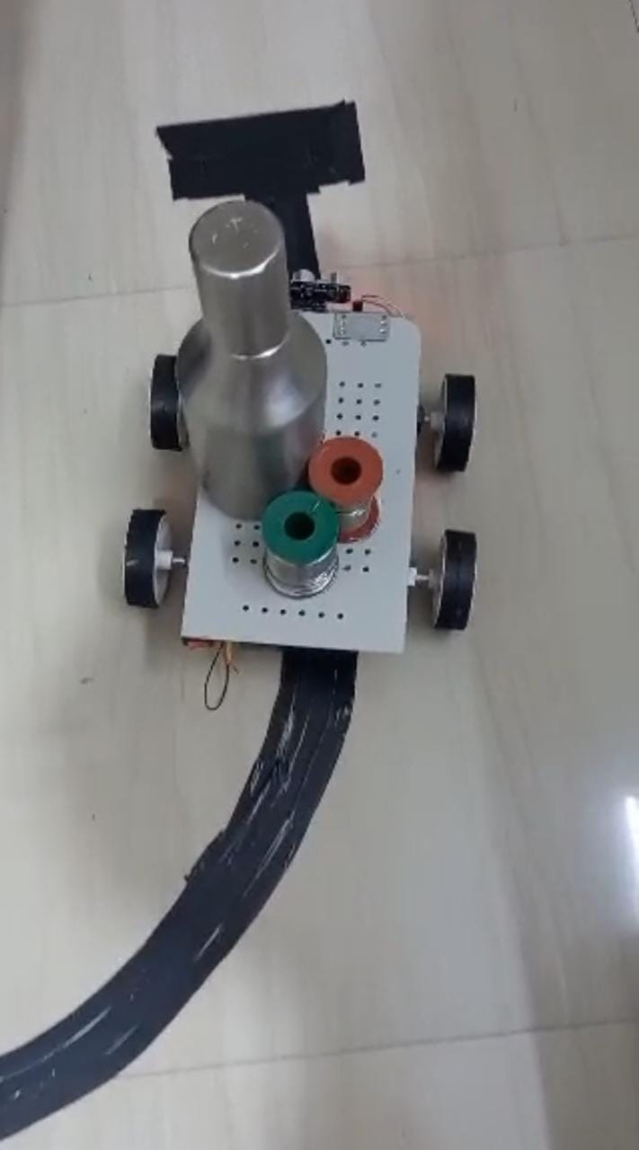

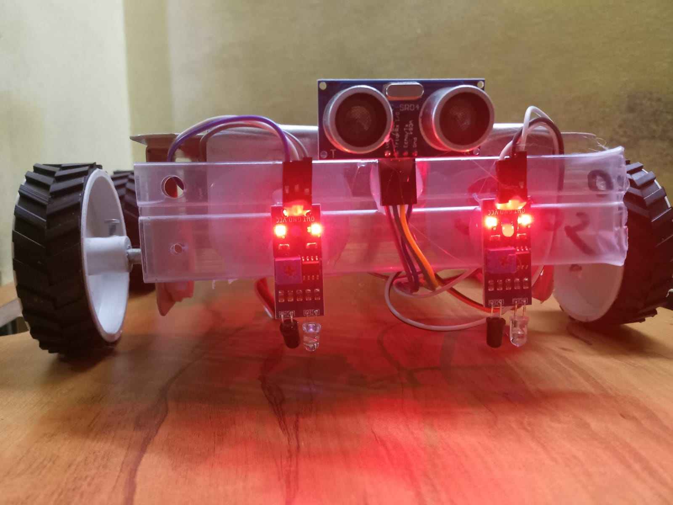

6.CONCLUSION AND FUTURE SCOPE

The "Transportation Bot" project presents an innovative and cost-effective solution for material transportation in small-scale and startup industries. By replacing traditional conveyor belts with an autonomous robot, the project addresses the drawbacks of conveyor belts, such as high initial investment, fixed routes, and space consumption. The Transportation Bot's implementation of IR sensors for line following, ultrasonic sensors for obstacle avoidance, and Arduino microcontroller for intelligent control ensures efficient and safe movements within the industrial setting. The project's successful integration of hardware and software components enables the robot to autonomously navigate along designated paths, halt when encountering perpendicular lines, and avoid collisions with obstacles. This technology offers increased productivity, adaptability, and cost-effectiveness to industries with limited resources, enhancing their material transportation processes and streamlining overall operations.

